DATE: 2018-04-10

**From:** Phoen, Eugene   
**Sent:** Monday, 02 April, 2018 1:59 PM  
**To:** Chan, Pei-Fong  
**Cc:** Tan, Melvin-JH; Lee, Kar Mei  
**Subject:** SKU master

Hi Pei Fong,

Can you pls help to amend –

* Rename “ABC” field to “Value” and change descriptions to –
  + A – high value
  + B – medium value
  + C – low value
* Add new field: “Order Freq”
  + A1 – fast mover
  + A2 – fast mover
  + B1 – medium mover
  + B2 – medium mover
  + C1 – slow mover

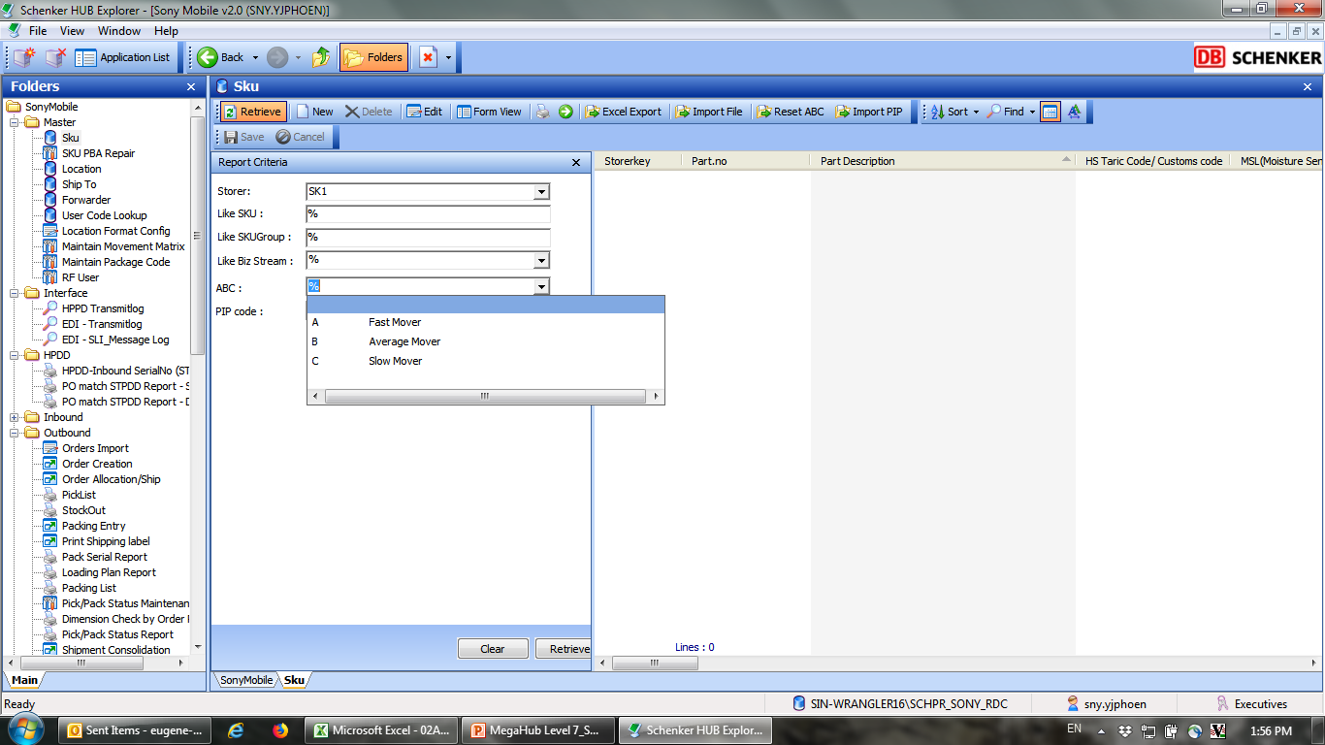

CHANGES:

SKU - orderfreq mapped to SKU.PickCode, codelkup.listname = 'SMODRFRQ'

1. Codelkup

|  |  |  |
| --- | --- | --- |
| Listname | Code | Description |
| SMODRFRQ | A1 | fast mover |
| SMODRFRQ | A2 | fast mover |
| SMODRFRQ | B1 | medium mover |
| SMODRFRQ | B2 | medium mover |
| SMODRFRQ | C1 | slow mover |

1. SKU Master

Update the ABC codelkup description.

Add new field PickCode to SKU master, label to “Order Freq”

|  |  |  |
| --- | --- | --- |
| Field name | WMS Field | Description |
| Order Freq | SKU.PickCode | Order frequency |

Add Retrieve criteria:

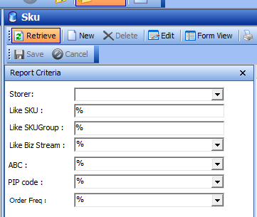

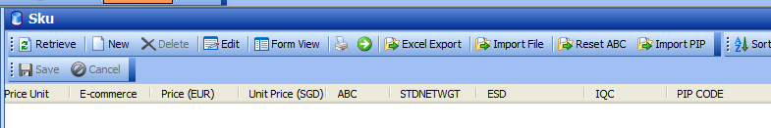

Order Freq